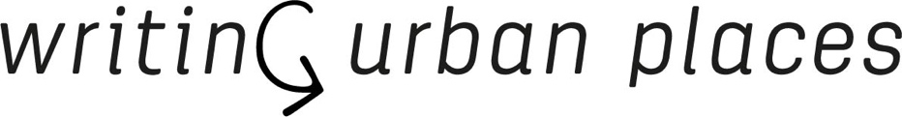
Core Group Meeting
21.01.2021

Present: Klaske, Susana, Luís, Slobodan, Jorge, Angeliki, Sonja, Carlos, Marcel, Kinga, Willie

Announcements
- Financial audit was submitted 20.01.2021. Hopefully we passed!
- Call for Papers Writingplace journal issue #6.
If we have output of our COST action, all participants need to be from members in the network. There could be a co-author or we invite them to join the network. The journal issues are deliverables, so part of the network.
Marcel, previous experience > the editors need to be COST members. The holders of the output should be COST members. Or, If the journal is published with COST Action money, then, all writers need to be COST members.
Kinga: and the number of authors is min. 3 from different countries…
Further research needed. Jorge will look into this.

Update working group 1
- Continuing like normal, only few active members, but good ones!
- Planning a meeting in February. They are thinking of a topic to discuss. Not only being operative, but also showing some output.

Update working group 2
- Shares the almost finished result of the mini-conference of Nov 17th> the booklet pdf
- Draft booklet to be circulated to core group members for final check, Distribute this booklet next week.

Update working group 3
- Working on the repository of methods and possible entries through the pallet website. Now they are selecting the work and what it can actually become.
- Webinar Wednesday 3th of March.
- Move from the idea of methods into an idea of assignments. Assignments to read, write and transform the city.
- Currently the members are trying to translate existing experimental methods into small assignments.
- Maybe a slightly different set-up for the webinar > more pecha kucha like short presentations instead of keynotes
- Final editing round of the journal. (Last round editors and then going to the proofreaders etc. )

Update working group 4
- Final preparations
- The program pdf will be distributed tomorrow
- How can people who are not part of the Action enter? Just through the zoom-link.
- Currently 61 positive acceptants
- Klaske will send the attendance list to Luis and Slobodan
- Maybe we can ask all the participants to share the slides and make a presentation. Just as a back-up. And afterwards you already have the material.
- Our expectation. The three themes Mapping, performing, sharing are somehow connected to the terms Meaningfullness, appropriation, integration. But we are not totally sure about the relationship. We will see if the thematic works also in relation with WG3.

*Note
- Use mailchimp > newsletters, booklets etc. Salma only for formal stuff: e-cost invitations, reimbursements etc
- Make a small media package for announvements of our network events. One tiny and one larger small with some disclaimers. “Better playing safe than calling the police''
- Luis and Slobodan need to get the slides from the Coregroup members to prepare the starting presentation.

Registration
- Only 50 % of the action members are represented on the webpage. Maybe another call for the members to send their profile for the website.
- Actually, what about the Brexit people. Are they reimbursed for future meetings, can their still apply for STSM’s etc?

COVID
- It is hard to know if we can sustain the dates for Porto and Talin.
- Porto is maybe better to postpone it to the summer e.g. September
- June will work for Tallinn, it is a smaller event and weatherwise timeing is perfect as it is summer then

Proposal by Michael Kelly, Limerick (WG2)
- How to incorporate this translation proposal?
- It is a great opportunity to work beyond groups. Interworking groups for the translation.
- We should set up the parameters for the translations. Short stories (e.g. 2 stories), so it can be used transversal. Tangible cities and Tangible texts. It can become very fun!
- Susana refers to another Portuguese project that was presented at the Almada meetings last year> Literary atlas Almada, Lisboa, etc.
- It will hopefully fuel the dynamics of the website and the network.

*Other
- Administrative question (from Olga). They want to know the dates and the participants of all the working group leaders etc. All from the new grant period. >>> Send all this information to Klaske & Salma. Just to have an account of the activities within the action.

Next meeting: Friday 12 feb at 16:00 (CET)

