COST Action CA18126 Writing Urban Places New Narratives of the European City
Core Group meeting
Friday, June 17 2022
Present: Klaske, Susana, Giuseppe, Jorge, Onorina, Angeliki, Dalia, Luis, Carlos, Slobodan, Kinga, Willie

Updates
- We did get the extension of another half a year. The full grand period 4 is approved.
- Next year they will calculate the budget differently > participating countries in working groups. Susanne thinks we are good but will double check.
- New applications arrived (probably from Tampere). Susanna will send these to all of us to double check.
- Susana and Jorge were at Brussels (Jorge managed to approach Michael for the book. COST cannot pay a publisher directly. The vicious circle is solvable > Grand holder institution pays first. In our case Delft pays and then gets the reimbursement. First step now is to see how Delft can deal with this.
- Klaske: we can only start making the budget for the book after we get the budget from COST for next year, which is this autumn.

Tampere Hiedranta workshop
Congrats!
23/24 participants (not all showed up)
Workshop + WG3 meeting (RoM discussion and a discussion how to activate this little booklet > Dalia is will note these down and share them)

- Luces’ visual methods > whole repertoire.
- Evening event with Dalia and Elina in a bar with local and activists
- Jeremy’s talk > with everyone ended up with a collage of poems.
- Dalia and Elina organised interview with activists
- Next day > 2 hours to synthesise > all the work was put together and presented in the house (not on the walls though)

The bulldozers where already there and demolishing activities were visible. On the pivotal moment. All people were happy that we were documenting the local initiatives. They were happy to exchange.

Yesterday > Elina and Dalia had to wait by taking the exhibition down since there were people who would still want to visit.

Now… postproduction. Maybe a student on a STSM grant can help with this

Canakelle workshop
> invitations are out.
40 applications. 21 participants
Program looks good and almost all is worked out.
Partnership etc is also on track
Currently working on the logistics.
STSM > the applicant is working on the same topic, but different situation. He will not attend the workshop since he must do other work. Currently Giuseppe asked him to give a presentation on his work which will be a pre-preparation lecture for the participants.

Skopje
17 applications so far - 3 places left.
In total 30 to 35 people (so with invited people etc.).
Next Wednesday the organizers have a meeting with the organizers.

Regarding the budget and the MC meeting.
Maybe it is not necessary to have the whole MC team over. A selected group in relation to the budget could also work. We should decide this before the summer (in the next 2 weeks).

Translation from Macedonian to English. Hours used for the organisation will be part of the loss. Salma knows the details about this.

BOOK proposal
See slides Klaske
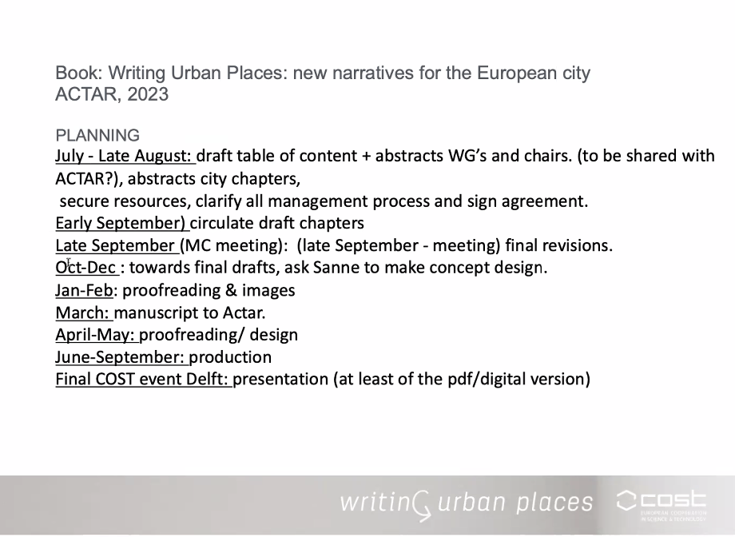

This summer we need to have a table of content + draft chapters. To get an understanding for ourselves and for the publisher.

- Luis - articles do not need to be a related to the workshops, but the city in relation to the topic.
- Angeliki - four working groups are responsible for the first part, but the working group leaders can direct to other participants within each working group.
- Angeliki - no time for external peer review. External proofreading for sure.
- Susana - the design time looks short. A lot of images which need to have a new scan. Graphic design with Sanne > from September on.
- Dalia - What is the space for the fieldwork events? Actar sad 240 pages in total, all colour.
- Susana- IMAGES HAVE copyrights. This might be an issue.
- Susana - E-book would open further with links to the website.
- Angeliki - pdf (digital publication) by next September (printed can be later for granting the money)
- Susana - who earns the money of the book. They earn a bit more. Only a second publishing round would grant royalties.

Invitation to all in the core group: no more than 1 page abstract of what the article in part 1 would be. Deadline would be in the next two weeks.

Regarding part 2 > all the cities presented, but maybe also have a good introduction (or… do we combine this with the last part of part 1). Luis and Slobodan can write this?

Ongoing projects
- NALANS - Sonja is not here
- Other destinations - Giuseppe
4 translations, 8 are ongoing.
The map related to the translation is also ongoing. There are 2 people who are a bit lingering… we aim to have the draft translations all done by the end of the so we can decide in what format is suitable.
- Repository of Methods - Dalia already talked about this. A lot of revisions have been done, so we need to organise a meeting with the team and proceed to next step. But there are still some new methods coming in.
- WPJ#7 - Luis – the editorial team had a meeting; extension of the deadline was a success. Happy with the results, not only with the text in general, but also the scope of reflections (from academic to experimental). 2 will work on a revision. First round of peer reviews can almost start.
- Vademecum - ran out of copies but the publisher sent a big box with more! able to hand the copies in Canakelle and Skopje
- The presentation of the Vademecum in Istanbul was a great success! Very interactive.
Onorina: Maybe Giuseppe can write a small text with images for the webpage.

- Preparations for second open meeting - let us know if you need a breakout room. June 29th

Next meeting
Monday 4, 11:00 CET

