COST Action CA18126
Writing Urban Places
New Narratives of the European City

Core Group / Strategic meeting in Skopje
Friday, September 30, 2022
Host Institution: University Ss. Cyril and Methodius, Faculty of Architecture Skopje

Present: Klaske, Susana, Jorge, Onorina, Angeliki, Giuseppe, Sonja (online), Dalia (online), Luis, Slobodan, Kinga, Marcel
Joined for the afternoon part (point 7 onwards):
Willie, Dorina (Tirana), Anna Ryan Moloney and Michael Kelly (Limerick, online), Eliana Sousa Santos (Porto, online),

9:30
Klaske opens the meeting and thanks Slobodan and the Faculty of Architecture in Skopje for hosting us. Presentation and approval of the agenda.
-The work and budget plan for GP4 will be discussed under point 3 instead of later.
-The guests for the meeting part on the book will join after 11am

1-budget updates
Klaske presents the situation regarding the budget op Grant period 3. Due to higher travel costs, higher daily allowances (COST annotated rules) and Local Organiser Support, all the fieldwork events and training school have been more expensive than calculated. This has been mitigated by changing this meeting (which was intended to be an in-person MC meeting) to a smaller strategic meeting with less participants, and by planning the MC meeting as an online event in October.
There is still budget to grant an extra STSM, and to realize the dissemination plans.

2-news on negotiations with publisher and COST
Due to the new EU COST rules for open access and non-for-profit publications, publisher ACTAR has withdrawn for the final book. NAI010 publishers, who have also published our journal issues and the Vademecum, has been more positive: we have a signed contract for the Repository: open access + 200 copies for the network. (In case of underspending of this grant period, we will obtain more copies with the rest of the budget). NAI010 has also responded positively about the plans for the final book. It can be realized as Open access publication and print on demand.
Jorge remarks that the book can be sold as print on demand, so that only the production costs are paid for by buyers. Commercial book sales are not possible according to the COST rules. We need to take this into account for the material and paper quality of the book: a small number of printed copies of high quality, and a print on demand option for further dissemination outside the network?

3-outline work and budget plan for the final year (nov 2022-sept 2023)
Klaske presents the draft work and budget plan.
We have 15% less budget than expected and the grant period will end September 14th 2023. At the same time, as it is the final year, we have high dissemination costs for making the final book and finishing all other publication projects. This means we are limited in our possibilities for meetings.

Current proposal (see meeting slides in pdf for more detail):
Available total budget 154.000
-- Meetings
Conference: May/June 2023, in Delft, 1 day, ±75 participants >74.000 euro
Training school/fieldwork: March 2023, in Tirana, 2 days, ±20 participants, ±3 trainees to be reimbursed > 26.000 euro
-- Grants
STSM, ITC, dissemination grants: total 4200 euro
-- Dissemination
Writingplace journal issue, Other Destinations, website, Final book: total 36.000 euro

Amendments:
Sonja: grant period goal #3 could be more broadly framed so that it could also include results of other working groups “publication of the outcomes of the theoretical and methodological research carried out in the network”
Slobodan: date for the final conference cannot be 7-10 June due to a conference in Skopje
The general Work and budget plan is approved by the core group and will be prepared for voting by the MC.

4. STSM grants
Kinga presents the state of affairs of STSM’s

- Sergios Strigklogiannis’ STSM on ’Urban Mythologies’ took place in June. It is finished and report approved. Kinga will approach the candidate again to provide a news item for the website

- Angeliki Sioli’s STSM ’My Osijek: Other Perspectives of Dwelling the City’ took place late August-early September in Osijej, the report has been approved. Result will be part of the chapter on Osijek in the final book, with Sonja.

- Holly Dale’ s STSM ’Props and Appropriation: Exploring the Everyday Narratives in the City’ is taking place alongside the workshop in Skopje precisely these days. Kinga will approach the candidate to provide a news item for the website

- New application: Mathilde Merolli, one of the participants of the workshop in Tampere, applied for an STSM to help with the post-production of the event: ‘Narrating Hiedanranta Archive: Stories to Keep Alive’ .
The core group discusses and approved the proposal.

-intended application by Willie Vogel for pre-production of the fieldwork event in Tirana is expected to be submitted in the next grant period.

4. ITC grants

- Pavel Horak ‘s ICT grant for the conference paper and panel session ‘Capital Magic: Esoteric Narratives and Shaping the Capitals of East-Central Europe’ took place in July. He will be asked to provide a news item for the website

5. Ongoing projects
-Repository of Methods
Editorial team Dalia, Esteban, Carlos, Klaske, Lorin. Is proceeding in full speed now to finish before the end of Grant Period 3, late October. 50 entries, proofreading and graphic design ongoing. Contract with nai0101 publishers for the production.
Questions: will ‘repository’ be the final title? It fits well with the ‘vademecum’, but final title and subtitle will be decided upon in the coming weeks
The team is also thinking about ways to ‘report back’ in grant period 4. Ideas: postcards at the back of the book cover, exercises at the upcoming events and conference.

-Writingplace 7
Editorial team Luis, Slobodan, Aleksandar, Klaske.
After a relatively slow start with extension of the call for papers, nine articles have been selected for review. The task for the reviewers could have been better formulated (we gave the call for papers but could have been more specific in the email invitation) as the texts are not conventional academic texts as they are reflections on fieldwork done by the authors, often in 1st person perspective and with notes, diary entries and sketches. Nevertheless, very relevant comments have been made and shared with the authors who are now expected to deliver their final texts. One article has been withdrawn.
Planning: final texts by Oct 8, then if they are good, on to proofreading and graphic design. We won’t be able to have the entire issue done by the end of GP3, but we hope to convince COST with at least the cover and some articles.

Other destinations
Slow but steady process, texts are being translated, some new entries, the project will continue in GP4. Budget has been reserved for it, the format is yet to be decided upon: journal issue, digital publication, something else?

Nalans
Has been delayed due to issues with the online platform, is now proceeding, still not clear if it will be done within this grant period.

Canakalle report
Giuseppe has taken the initiative to publish the results of the Canakkale workshop in a small book. It will be realized within this grant period, and we are looking forward to seeing the result.

6. Planning Open meeting + MC meeting online
19th of October, 13:00
Agenda:
Opening,
Presentation of the Work and Budget Plan,
Update of the working groups,
Ongoing projects.

7. Activities Grant Period 4
Apart from the core group, the guests for the rest of the strategic meeting join:
Dorina, Willie, Michael, Anna, Eliana. (core group + guests)

-Tirana fieldwork event / training school, March 2023
Dorina and Willie present the ideas for the Training school/ fieldwork event in Tirana.
Topics: transition as a constant feature, commoning as practice of appropriation and of making/defending meaning of urban places. Planned and unplanned urban sites
Workshop will be hosted by the Institute for (or Faculty of?) Anthropology in Tirana.
Methodological approach: embodied exploration, filmmaking.
Questions/suggestions:
Jorge: it can be useful to have a clear working hypothesis
Slobodan: planned and unplanned is interesting, what about quasi-planned?
Angeliki: could the unplanned even be a methodological perspective, allowing chance in the process?
Klaske: Tirana is the first event that takes place when both the Vademecum and the Repository of Methdos are available. Could they be used?
Slobodan: the call for participation should be well prepared and announced in time. There is now experience form the previous events. Slobodan and Luis will be in contact with Dorina for this.
Willie plans to apply for an STSM for the pre-production in Tirana.

-Writing Urban Places conference, Delft, May/June 2023
As the final grant period will end already in September 2023 (instead of Oct 31), we have to organise the final event before Summer. Best times seems to be late May – Early June.
Agenda for the conference: presenting the outcomes of the COST Action: most logical seems to have the final book as framework, plus highlight some of the other activities and projects.
Due to budget constraints, it can be only 1 day, so it is challenging to organise a workshop within the available time.
Angeliki proposed (with Saskia de With from WG2) to focus on cemeteries, as urban places of stories and memories. There are two cemeteries very close to the faculty in Delft so they can be visited easily. A prior exercise can be done by participants, sharing stories of their home town cemeteries.
The proposal is well received.
Dalia proposes to have a slot at the conference to report from the repository: at the first Open Meeting in 2023, a call can be made to report back, and the results can be presented in Delft
Jorge brings up the issue of audience: who do we want to invite, apart from the members? Are we talking only to ourselves, or also to outsider who can bring this further? Who should these people be? Famous academics and designers? Or Eu politicians, mayors and other people involved in urban policies? Everyone is invited to think about possible target audience - not only for the conference but also for our social media and book.

8. Closing event

The meeting is closed at 17:30, to be able to attend the event in front of the Faculty of Architecture, three acts about Skopje’s brutalist architecture, performed in a temporary installation designed and built by the workshop team, as a result of our Fieldwork event in Skopje.
Many thanks to Slobodan and the Skopje team for hosting us!

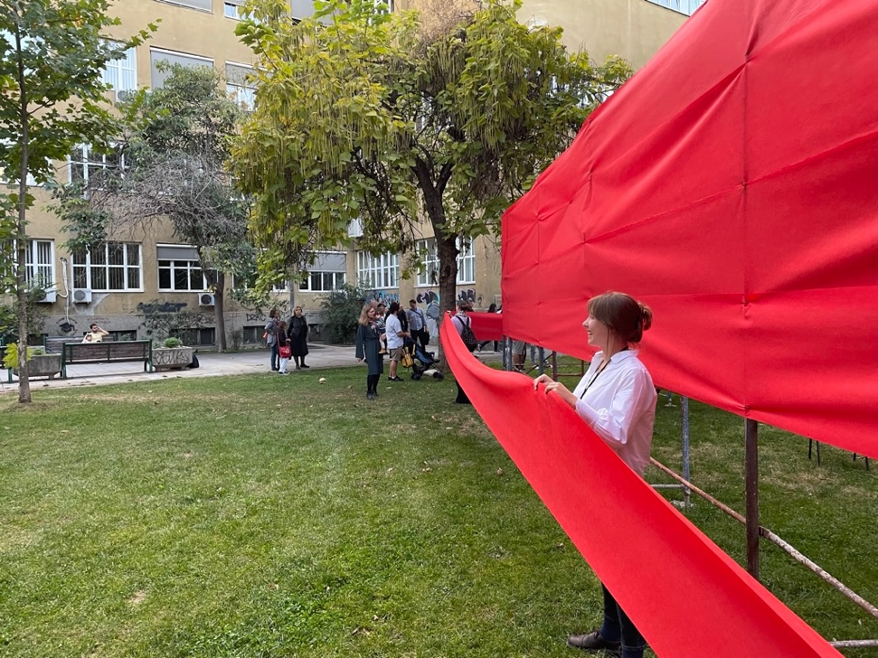

Zoom link_________________________________

COST Strategic meeting / Zoom attendance
https://tudelft.zoom.us/j/95523336202

