COST Action CA18126
Writing Urban Places
New Narratives of the European City

Core Group
Tuesday, January 24, 2023
Online
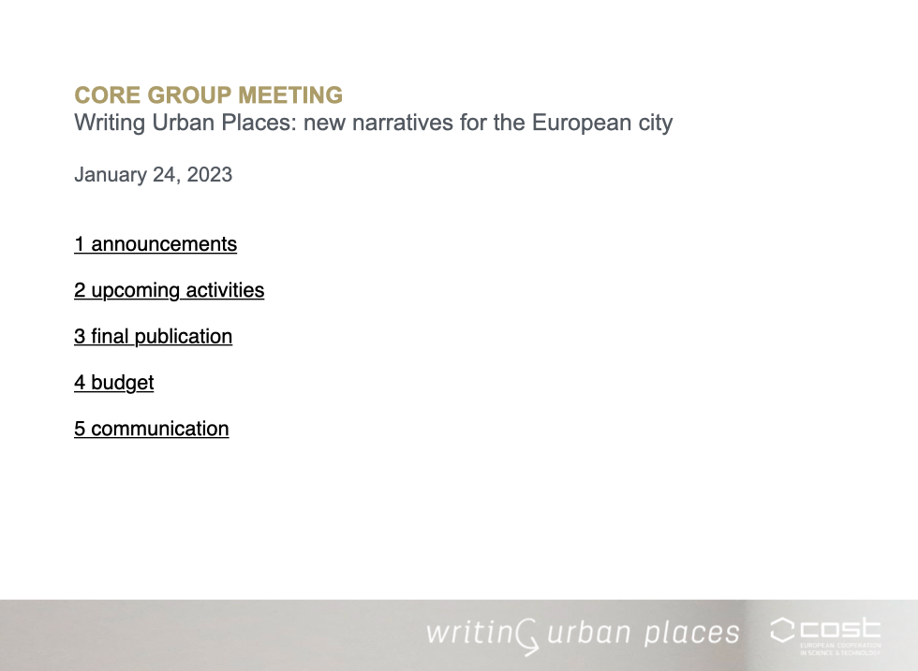
Present: Klaske, Angeliki, Giuseppe, Dalia, Luis, Susanna, Willie, Sonja, Jorge, Carlos, Dalia, Holly, Slobodan, Onorina

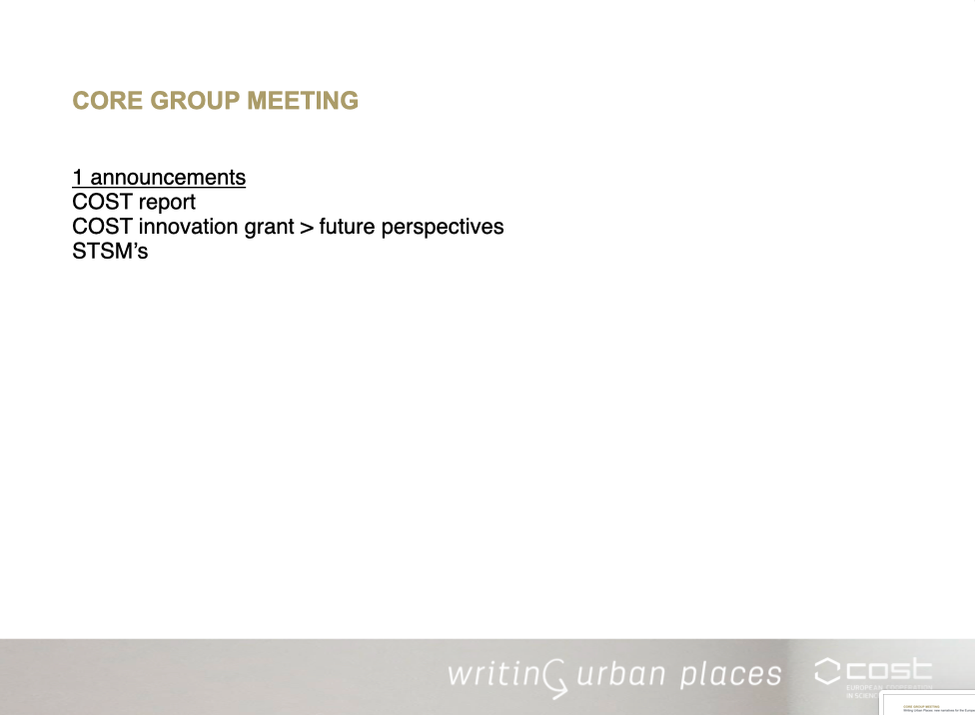
Announcements

1-COST Report
Jorge: COST Report from March 2022
- Generally positive
- Negative comments - low quantity of deliverables, Jorge believed is solved as from March 2022 we have published a lot since then.
- We have fulfilled most of our objectives.
- We still have a few objectives to do; however, scoring lowest when engaging with citizens beyond academia.

Klaske: Thank you Jorge, perhaps we should take this into account when we have the conference, and invite people from cities we have visited.
Jorge: In the future we address writing a policy brief
Klaske: Let's write a response to the report to the points they raise.

2-Innovation Grant
Klaske:
- Susanne, Jorge and Klaske have been investigating whether this would be a feasible project
- We would have to come out with a business plan of how it will work in practice
- We may not suit the innovation grant so we should look elsewhere

3-STSM
Klaske:
- Willie completed here STSM in late January and has submitted her report
- There was an application for a virtual mobility grant, it was quite off topic so we have not accepted it

Meeting agenda

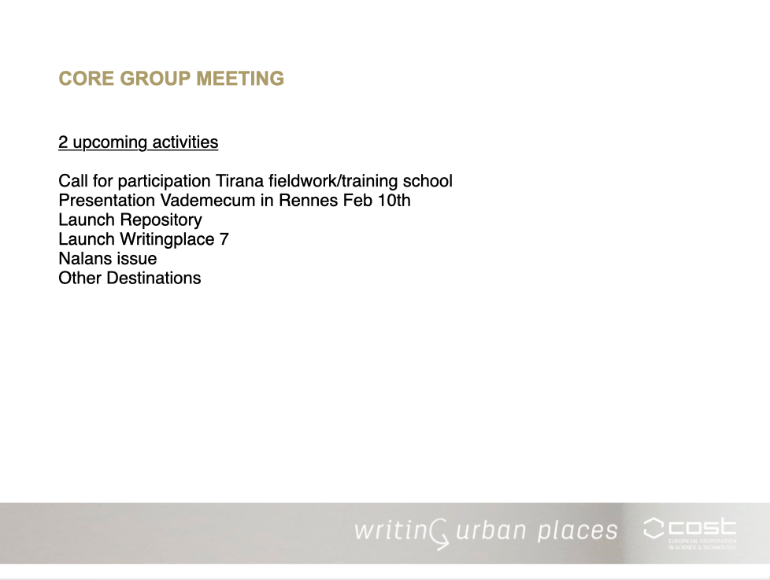
2-Upcoming and ongoing activity

Call for participation Tirana fieldwork/training school
Slobodan:
- The call was announced this week - we have to check the text and dates
- WG4: reviewing call - since our last core group meeting, the call has been reviewed and updated
- The topic is very interesting and very well organised with COST action
- We will check the call, if this is the final version (if not: take call down and upload when revised)
- Who will go from working groups? Discuss when Dorina + WG4 makes selection

Vademecum presentation in Rennes, France
Giuseppe:
- They are working on definitions of terms, super interested in our work
- Asked us to present the Vademecum
- Maybe we will do an interactive workshop alongside presentation to get a response
- 10th Feb

Repository of Methods
Klaske
- Online version launch soon
- We may also organise an online event but not confirmed yet

Writing Places #7
Klaske
- Missing three articles from the layout

Nalans
Sonja:
- 6 articles under construction, 4 are finished

Other Destinations update
Giuseppe: in progress, most translations ready, Jorge wrote the introduction, the texts will be proofread.

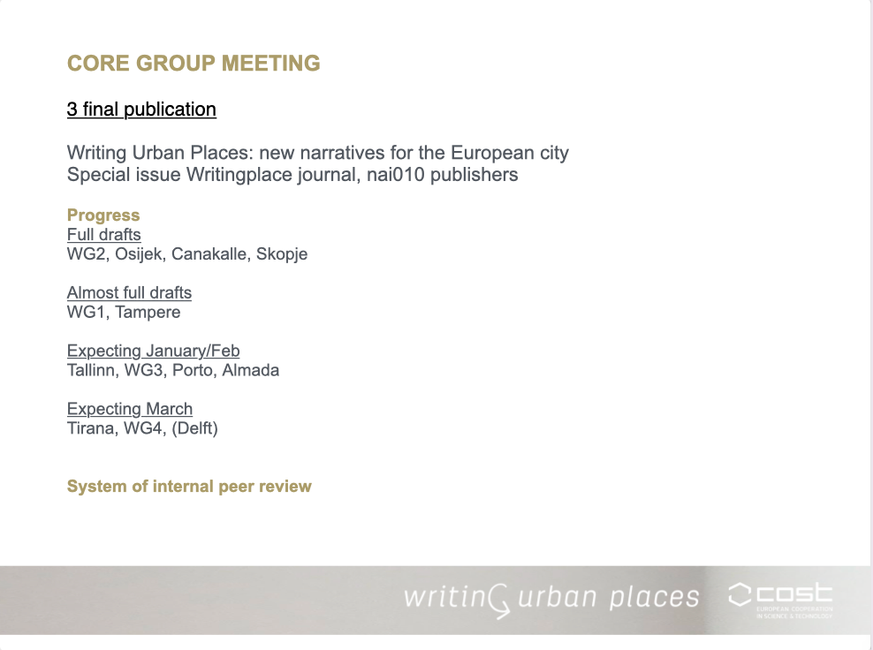
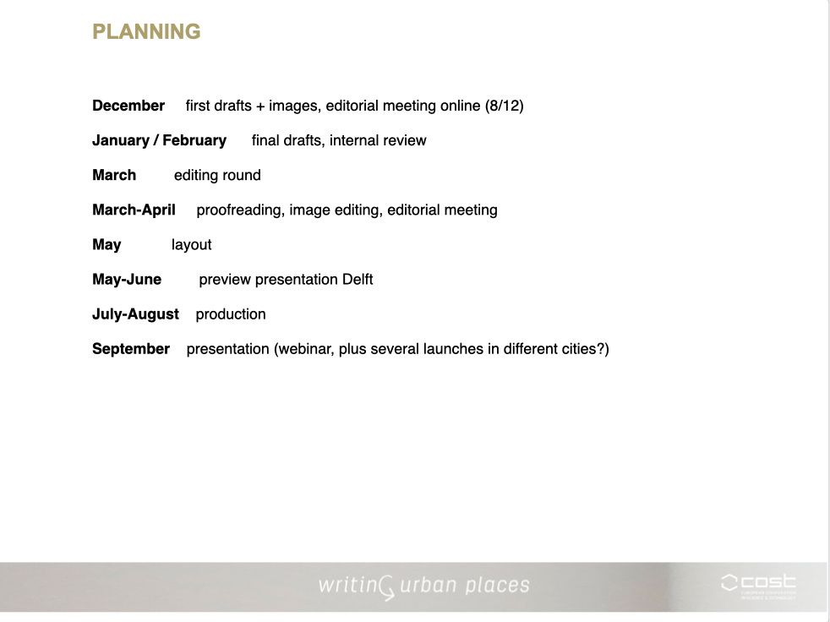
3. Book Progress

Slobodan: Could each chapter consider in their introduction discussing events/outcomes which happened as a consequence of our activities? Links to real life and public of city?

Klaske: I don’t know if it applies to all cities, however, it is very interesting to address the impact our activities have had locally

Sonja: Our event was an awareness raising event so it worked as an outreach in a smaller way. Links to students and they responsibility in the city.

Slobodan: Sounds great, should highlight small impacts of events and practice of everyday life. Phd students may be policy makers so even if the event did not directly effect public it may do in the future. Good to bring these topics forth.

Dalia: Raised question after last meeting, should text be open variety?

Klaske: We will have multiple authors, viewpoints, and activities. We also discussed in the last meeting would there be themes, it was not to well received so perhaps we stick to structure of working groups and then cities.

Sonja: first, we should have all finished papers then systemise

Dalia: I agree and disagree, it could affect how working groups write text.

Sonja: I strongly believe we should receive the article and then do the structure.

Klaske: I agree

Slobodan: The dilemma is not the structure of the book but also the structure of the text within the book.

Dalia: I see working group texts as a form of introduction

Angeliki: We have had similar conversations, this is only the first draft, place on the paper what heart feels like and then we can fine-tune. We can make connections later. These are the first drafts. Don’t restrain yourself.

Klaske: Internal review process: WG2 has been read and given feedback by a member of the Action (Vsva Riesto former WG2 leader), we think all texts should be read by a member of the network for feedback.
All full drafts in Jan/Feb, feedback in March, late march to June period of proof reading and working with layouts so we have something to present in delft, after delft final production.

4. Budget
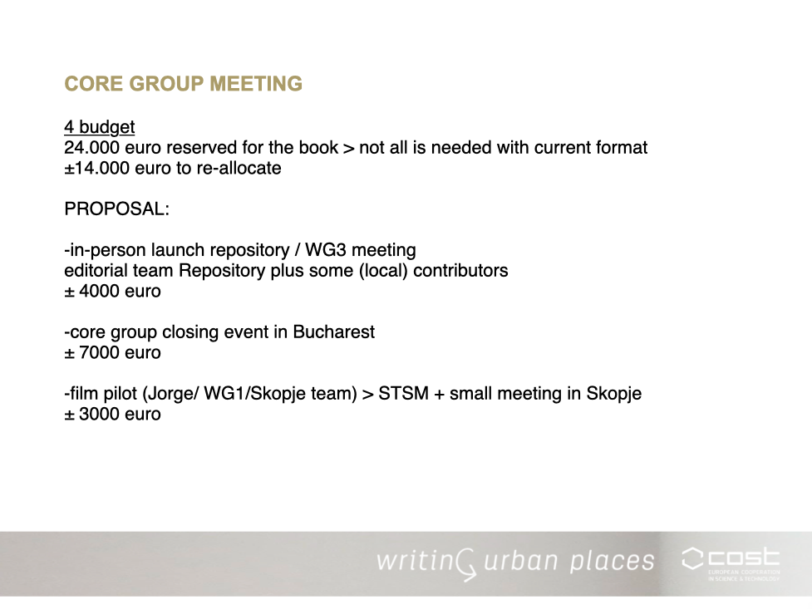

Klaske

- We have 14000 euros to reallocate for this year, as we won’t have as high production costs for the book as expected.
Here are some proposals of how we could reallocate the money.
  - Repository, the small in-person launch of the repository with WG3 and contributors.
Dalia: launch could be in Tampere, I could try and ask for some money off the university to bring 2 people over as well.
  - Core group closing meeting. June is final event for whole action. Could we have closing event in more intimate setting with core group. Could be a moment to look forward? Bucharest has been on the list, this could be held in September.
  - Film. Smaller film project in form of STSM with small meeting in Skopje.

Jorge: Film. Several short film invitations been extended to groups such as, Onorina, instagram compendium. Video and film are easy material to engage with for the public. All recent events Skopje was not registered in film, so let's go back and make small after the fact film. The invitation is to everyone in what way they can contribute to strategy.

Dalia: I was confused, have we decided to do this?

Jorge: We have not decided it is a proposal, let WG1 know if it is interesting.

Klaske: So the current films proposed are: Film from Tirana, Instagram (WG1), Skopje (STSM), other events?

Carlos: How many films will be made?

Jorge: Anyone who has initiative to record work in topic of action and records in small film can do so. They can be placed in conference, and give back to places we worked in the form that is not a text. We can provide editing help, in WG1 we have a professional.

Dalia: If we compile all videos, can you then put it together?
Jorge: Send me an idea in an email and we can discuss what is possible with the material you have.

Klaske: Each of these films can be different in terms of format, theme etc.

Jorge: It is an open invitation, perhaps they are all separate but perhaps they work together.

Klaske: I will place suggestions in e-cost system to check it will work.

Sonja: What is in person launch of repository? Does it need 4000 euros, could it be reallocated to another STSM?

Klaske: Repository launch involves travel and accommodation for 8-10 people coming to Finland.
The estimate is based upon our previous experience. For instance, the training school was more than 20 000 euros, in Osijek,
a little less in Tallinn with a smaller group and only 2 days.
Core group closing event in Osjiek was 4000 euros. Core group Tallinn 12 people was nearly 8000 euros.

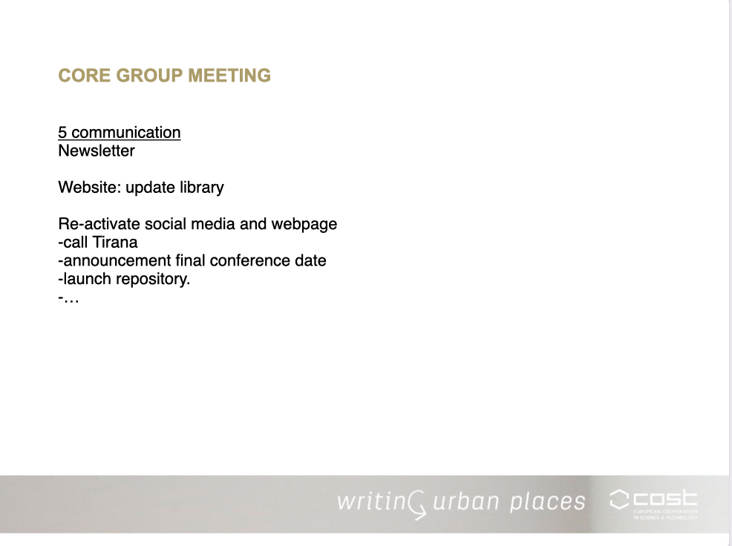
4. Communication

Jorge
- Two newsletters being made
- Holly welcomed
- Webpage - update library
- Short films
- We are making concrete tasks to get activity produced.
- The deadline is June 2nd

5. Final comments

Carlos: Minor concerns about book and financial issues with the repository (KH: will be discussed within repository team)
Giuseppe: We will try to work on short video in next days
Sonja: Wishing everyone good luck in endeavours.
Slobodan: Very nice meeting, nice to see you all. Very happy to work on short movie for Skopje, it is a nice way to approach broader audience. Are Angeliki and Saskia De Wit planning date for delft?
Klaske: Next core group meeting we will discuss the conference in more detail
Dalia: What happens with website after?
Klaske: we will find a way to keep it alive: continue the subscription with the webhost.
Sonja: In future projects it could be hosted in
Dalia: I am concerned about time for video, I hope to support in someway but I have a lot to do
Klaske: Don’t worry, it is an invitation not an obligation
Klaske: Thanks everyone, I am very happy with how everything is coming together, congrats
Angeliki: I am not receiving core group emails. Please check my email is there.

