COST – Coregroup Meeting
17 September 2021

@Tallinn Estonian Academy of Arts
Present: Jorge, Carlos, Susana, Sonja, Dalia, Luís, Kinga, Marcel, Kinga, Slobodan, Klaske, Willie

[photo group?]

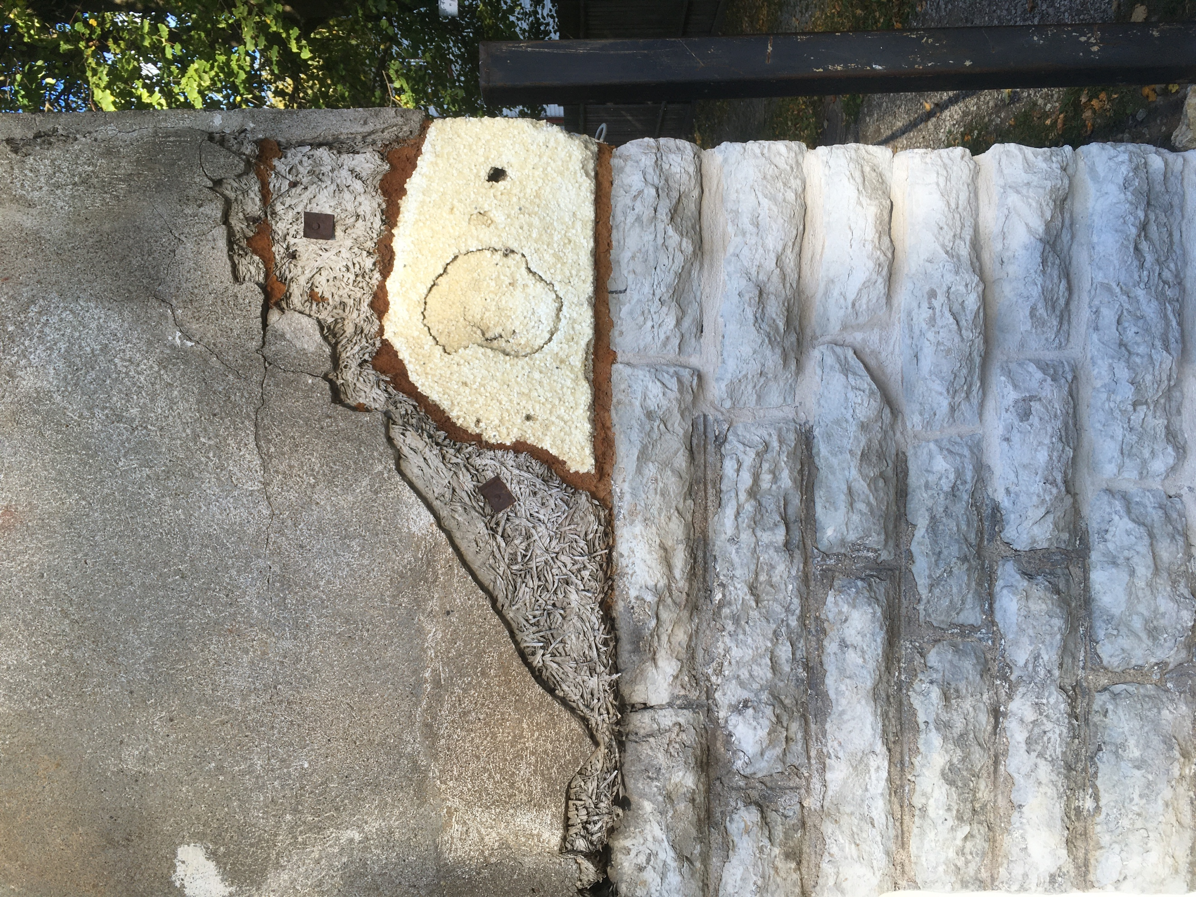

- Draft proposal Midterm Conference – Carlos and Suzana
Tentative proposal:
Venue – Porto school of architecture
26 October afternoon working group meetings.
@ Siza pavilion. This building allows a nice interaction between inside and outside.

27 October morning MC meeting > votes etc.
27 October afternoon > conference
@ the auditorium. 2 rooms for normally around 200 people (with COVID restrictions each room can host around 70 people).

28 October > possible for complementary activities
two people from projects around Porto we could visit
- Urbinat cities (https://urbinat.eu/cities/porto/)
- Prochild (http://prochildcolab.pt/en/home/) - 1,5 hours away from Porto, but we could also ask them to come to the faculty to give a presentation.
The projects could benefit from our experience, and we might benefit from their approaches.

29 & 30 October would be nice to stay and see the city
- Casa de Architectura major institution for architecture dealing with archive. On the 29th is the opening of a new exhibition opening on Portuguese architecture. On the 30e there is a conference for this. Besides, there are some other interesting exhibitions.

New plan: 27 and 28 October > just merge the activities in two days.
Wednesday 27 OCTOBER — Mid-Term Conference
Morning: Current state of affairs / Presentations of the activities developed so far
Afternoon: Discussions on the cities and fieldwork activities for the subsequent years
Venue: Porto School of Architecture, Fernando Távora Auditorium

9:00 - 9:30 — Welcome and registration (coffee)
9:30 - 10:00 — Opening address (KH, SO)
10:00 - 11:00 — Short presentations of each of the 4 WGs (10/15 minutes per group)
11:00 - 11:30 — coffee break
11:30 - 12:00 — STSM, ITC, Training Schools
General presentation of STSM (5 minutes) KK
Presentation of 3 STSM (5 minutes each, eventually video), PC, CMM, E?
Presentation of ITC grants (5 minutes), MP
Presentation of Training School (15 minutes)
12:15 - 13:00 — Presentation of the 4 webinars (PDFs, videos, etc.). 4 people from each webinar (10 minutes)
13:00 - 14:30 — Lunch
14:30 – 16:30 — Cities and fieldwork activities for the subsequent years
Introduction and strategic view: the framework (core group) 10 minutes
10 cities presentation and discussion
16:30 - 16:45 — coffee break
16:45 - 17:30 — MC meeting (1 h) (eventually with zoom)
presenting the next year, votes, budget plan, etc. with Q&A
17:30 - 18:30 – Books and drinks
Launch of Vademecum (Nevena Dakovic, moderator; Angelo Theokaris, Wille Vogel, Saskia de Wit)
Launch of Writingplace Journal issue #5 (Lorin, Jorge, Mark, Klaske; Anna Ryan, Luc Pauwels, Viktorija Bogdanova, Esteban Restrepo Restrepo, Kristen van Haeren, …) tba
Ongoing calls and announcements, invitations:
- Preview of EJIHPE Journal issue
- Journal of Narrative and Language Studies
- Writingplace #6
- Other Destinations: Translating the Mid-sized European city

21:00 — Dinner party

Thursday 28 OCTOBER — Complementary activities
Venue: Porto School of Architecture, Carlos Ramos Pavilion

WG Meetings
Optional programmes
9:00 - 9:30 — Welcome and registration (coffee)
9:30 - 11:30 — WG meetings
11:00 - 11:30 — coffee break
11:30 - 13:00 — Joint WG meeting
13:00 - 14:30 — Lunch
14:30 — ProChild CoLab presentation (FAUP?)
Urbinat: participated visit of Campanhã (2 hours)

NOTES
*Elections on the 26 of September in Portugal can cause some delay in reactions from the external parties for the conference. Everyone is waiting until the voting after which new plans (and budgets) can be made.
*Costs > getting the reimbursement for the travel + a flat rate of 175 euro per day.
*Would it be possible to sell physical copies of the vademecum and the WPJ since they are open access? It would be good to leave some of these at the bookstore of the faculty. To do this we need to contact Nai and ask if they could send some of the works to Portugal. (Action Klaske/Willie)
*Webinar PDFs – is it needed to make a publication out of this? General opinion is that it could be helpful. The compilation of the four together is just a short book as a guide is helpful and is an acknowledgement of each members work.
*Filming: the conference would be a good idea so we can post it on the website/Youtube.
*Nr of participants: About the nrs of the participants it is good to make the call on E-Cost with a limit of answering the call. Then we have an idea of the amount of people coming to the conference. This would be around the first of October.
*Hybrid voting for the MC meeting. Also, this voting session will be distributed through the e-cost meeting.
*Lunch – let people loose and mainly give just some recommendations.

- Workshop/Training school proposals
See also Excel made by Carlos
NOTE: Media Strategy (Jorge)
The proposal is to avoid two things:
- That our work remains autonomous
- The lack of a real impact on society/ the people living in the places.
This can be done by adding another layer in each project > adding a media strategy. How to activate the local media channels!? Rather than going (only) to major/municipalities etc. more awareness can be generated or activated with a media strategy. This reaches probably more locals. Think of: Newspapers, tv, radio, journalists, films, social media community etc.
Try to be multifaceted > you need to be able to play with everyone. So, in the strategy multiple local municipality media should be incorporated. How this works is for each context different. It is important to adjust the work constantly with the media strategy. Not try to write some small paragraph at the end. It is not that we make something sexy enough to capture attention, it should be a plan.
*To foster this process, we will have to organize a meeting with all the workshop/training school organizers only about media strategy.

- Osijek @ Sonja - TRAININGSCHOOL
Spatial temporal narratives and the Urban experience
Theoretical orientated.
4 hours of lectures.
2 novels (female authors from 2 different times, both chronical experience the everyday life of Osijek)
It is a walk + readings.
Lecture on Space in literature.
- When: Early Spring (march, April, May (would be best to get easy access to the town))
- Duration: 2 days and 3 nights. 160 euros flat rate.
- Host: University of Osijek
Content wise it is interesting! Linked to Tallinn and the myths here, in Osijek sounds very good literary connected.
It would be nicer to have some more time. E.g. 2,5 days or 3 days. Another half day to wrap-up.
+ Sonja can bring some wonderful wine and food.

- Tampere @ Dalia - WORKSHOPS
Methods day – related to the activating part of the WG3 webinar. This workshop has a special interested toward oral stories.
The site: the building complex of Hiedanranta.
Three days hands-on work.
  - Day 1 methods to gather all the stories. Gather the voices
  - Day 2 methods to analyze the stories. Put in practice the analytical methods.
  - Day 3 methods how to present
Non-hierarchical, so everyone needs to be involved in the work.
The university has a space at the Hiedanranta which we will be used all the time. There are different kind of buildings which are very interesting to analyze.
- Duration: 3 days
- When: Planned around June. Wednesday, Thursday, Friday
- Host: University of Tampere
To consider which methods brought in by the participants are practical or not will be done through a preselection.

- Skopje Slobodan – workshop + training school
Inspired by a cultural cooperation which brings certain qualities back to specific redundant buildings/areas. They use the narratives of the inhabitants and create a performance based on the values of the building. Authorities often don’t know what to do with the space.
We want to be part of their third project: the old post office building (very brutalist building). An old public building van the \60 but currently in decay.
Participants: is custom made for COST and the students from Skopje. Students from other universities are also welcome.
- Duration: The workshop will 3 days.
- When: June or September. The idea will be developed for 3 more days.
- Hosts: the city of Skopje and the faculty of architecture. For the site they pick the building itself.
Discussion point is to have an art performance at the end of the first day as this would cost money. If not!? Then they will just give a presentation and, they are willing to help and tutor.
A possible outcome for the project would be to write scenarios for the building incorporating the three major concept of this action (meaningfulness seems most fitting). By reading the place new programs for this building could be explored.

- Queering culture, writing the city – workshop Marko Jobst
Site: Belgrade, Serbia or Glasgow
REACTION:
- He has a clear method and wants to do a workshop with this.
- Might be interesting for the workshop in Tampere!
- How to develop this workshop in a clear site? How would it work when we situate this?

- The city and the myth - Canakkale – Resta
REACTION:
- Currently the proposal is too chaotic and should be filtered in terms of workshops and ideas. How are the days structured?
- The story of troy is a bit redundant so it is maybe better to pick one of the other texts proposed. Besides, he must narrow it down to two texts.
- What is clear and good is that he proposes a local organizer and an idea of a walk as starting point for a photographic exhibition.

- Lived Stories: Mapping homelessness in Potsdam – Research and Community development Circle
REACTION:
- Seems very interesting and also already has a clear target.
- We will ask to provide a better program.
- Potsdam is perfect, almost berlin, but fine.

- Trencin City Centre urban visions versus reality, SLOVAKIA
REACTION:
- This proposal is much more unclear. No clear target group and no clear goal and program.
- Maybe ask to pick one of the two with the suggesting that the previous one is better. For Porto she just must develop further. Let’s see if she can bring it to another level.

- Limerick & Two proposals – workshop
REACTION:
- The proposal is not clear yet.
- Also, there is two times Limerick and we have already been in Limerick.
- It would be good to take one of the proposals and develop this one further.

- Memory Bridge – Valetta, Malta
REACTION:
- Too long! It takes around 8 months. Main question would be to bring it back to a workshop/trainingschool of 2 – 3 days.
- The old Abattoir is an interesting space, but it doesn’t focus on the on the number of days we set of a training school/workshop.

Other proposals to come:
- Riga: Dace Bule
- The girls from Albania, Dorina Plummi and Marica …
- Angela Mensing: Gorlits

What are the criteria we are looking for? Could we write down a list where we are looking for. We can send this to the interested people:
- How many participants?
- How many days?
- Where?

When we come together at Porto, we will decide of the amount of trainingschool as we need to send the budget plan to Brussels a couple of days after.

Next step > how to connect this to the STSM’s.
- We could link a STSM call to the city. For example, a participant could come earlier and then already start with some archival work. This could already be initiated by the hosts of the trainingschools/workshops.
- Other option would be that some participants develop the project/research further after a trainingschool/workshop.

- Communication
We must move from communication to dissemination. From communicating internally to externally. As a group WG1 has fulfilled our first targets (webpage etc.), now we hope to move our attention outside and put a someone else on this internal communication. WG1 can then move to start working with the projects and with the groups who have projects running locally.
Is there someone who would like to take up this role/task? > Willie, Sanne, fatma (?) will join WG1
Marketing agencies could help us with this too … How can we work with Boutique? This contract was only for 2 years so we can think now of a new contract.

- Work and Budget plan notes
26 November 2021 - dissemination meeting vademecum in Copenhagen organized by Svava and Henriette. It is connected to the program/event running there.
25-27 April 2022 – PhD Training school + WG2 meeting / core group meeting.
Zie Notes KLASKE
*Translation project. For the call we have little people submitting work which really fits the call. There are only 10:00

BUDGET
Our budget should be spent by the end of this 2nd year. It cannot be reallocated to the next year. We will not be able to spend it all, but we have at least enough to invite everyone to come to Porto! Costs for editing, graphic design of the current WPjournal could best be made still on this years budget. (action Klaske)
We will get 187.000 euro for next year. The next grant period runs 1st of November 2021-31st of Oct 2022
---
Ingredients for the new work and budget plan based on todays meeting and ongoing initiatives:

1 / MEETINGS (preliminary schedule)
November core group / webinar
26 November 2021 Copenhagen
Dissemination meeting Vademecum, University of Copenhagen
Organised by Svava and Henriette + WG2
Feb 2022 Limerick
25-27 April 2022 Osijek
PhD training school +WG2 meeting / core group
Spatiotemporal Narratives and the Urban Experience
Osijek, Croatia (sonja / WG2)
1-3 June 2022 Tampere
Tampere workshop +WG3
Narrating Hiedanranta: Stories of Objects and Subjects of Urban Places
Host: Tampere University
Local team: Dalia Milián Bernal (WG3) Elina Alatalo (WG4)
Panu Lehtovuori (WG2) Meeria Vesala (WG3) Veera Turku (WG2)
September 2022 Skopje
Social Generosity of Space – Public Buildings for Public Spaces + WG4
Skopje, North Macedonia
Host: Faculty of Architecture, Skopje
workshop with students and young researchers
meaningfullness, memory
MC meeting October 2022
Graz?

Other options from call for proposals--
Valetta / Malta
Potsdam
Limerick
Glasgow/Belgrade?
Tirana: Workshop cities in Transition
Canakalle

Dresden/ Gorlitz (Germany)/ Workshop with local stakeholders (Angela Mensing)
Riga: harbour narratives (Dace Bula)

OUTPUT / Publications
-Translation project ‘Other destinations’
-Mid-term conference proceedings / report
-Special issue urban cognition -Marcel, Carlos, Klaske (eds) > author fees? 3 authors
-journal issue #7 ? WG 4 fieldwork: ‘pool of projects’ / narratives of european urban places
-journal issue #8 ? WG1 how to speak?
-journal issue through Narrative and Language studies (proofreading costs)
-outcome fieldwork events: readers
-repository of methods
-publication outcome of the Tallinn training school

STSM
open call, 6 STSM’s?
possibility to relate these to fieldwork projects?

ITC grant conferences: actively promote conferences in the field
6 grants?

other costs:
website: boutique

Core group > continue the 3 or 4 week-regular meetings.

TO DO
* Map of all the (proposal) places. – Willie
*Check amount of trainings schooldays with COST – Klaske
* answer the people who wrote a proposal back - Slobodan and Luis

